Ministry of Education and Science of Republic of Kazakhstan



**Department of Computer Engineering and Information Security**

**REPORT**

**Beauty salon**

Submitted by: Mukanova Madina

ID: 27656

Group: ITSE-1907

Almaty 2021

# **Content**

1. Title page
2. Introduction
3. Main part
4. Conclusion
5. References

**Introduction**

The Beauty Salon project is a website from which you can search for makeup or hairstyle masters, etc.

The website interface is based on HTML, CSS

**Main part**

HOME PAGE:

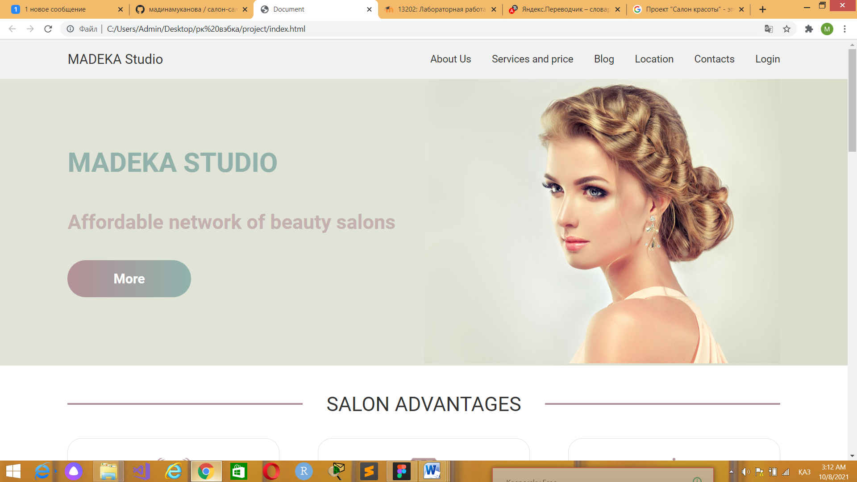

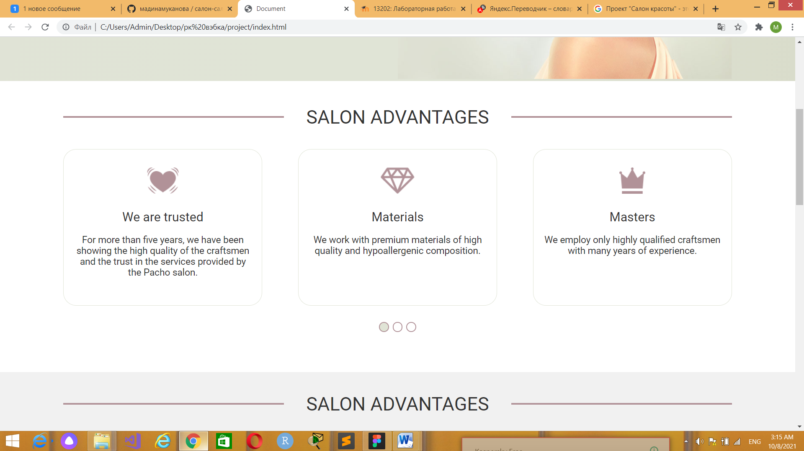

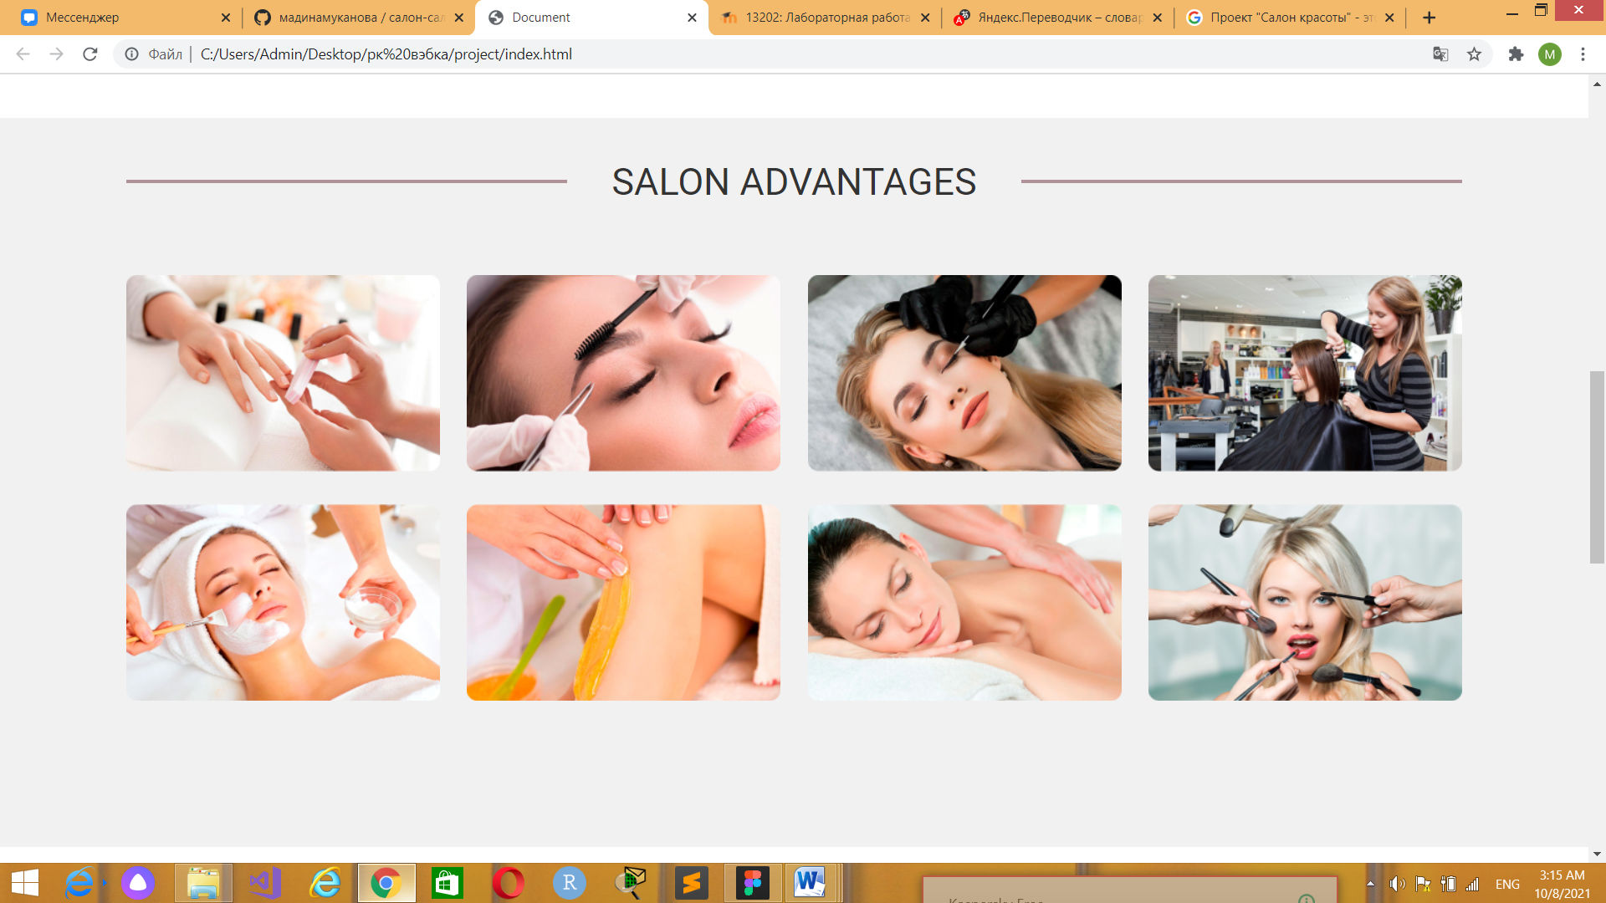

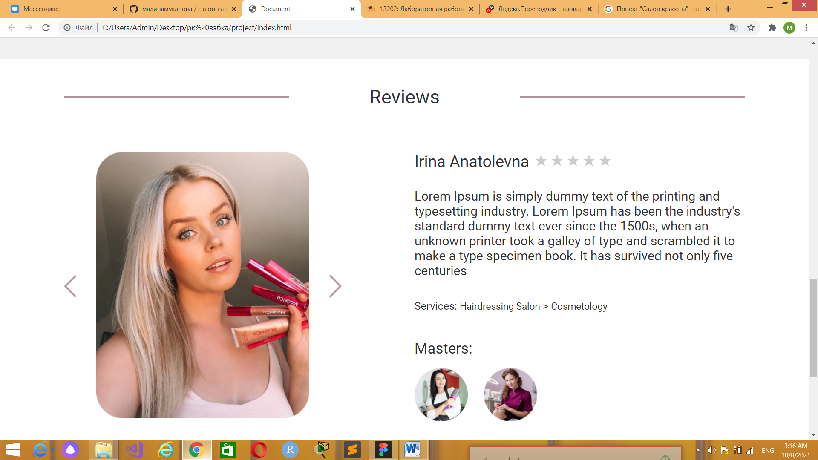



ABOUT PAGE:

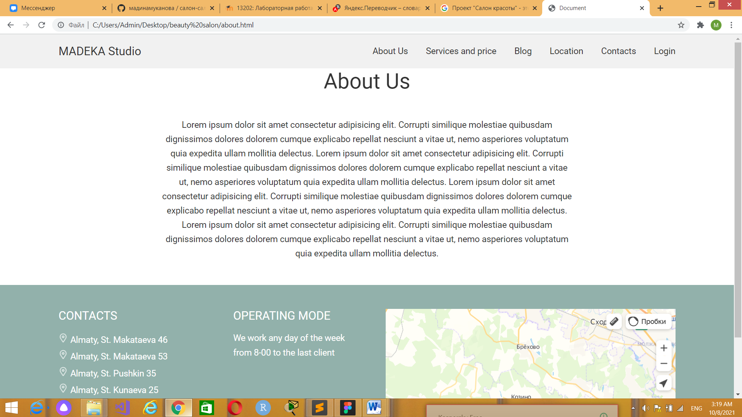

LOCATION PAGE:

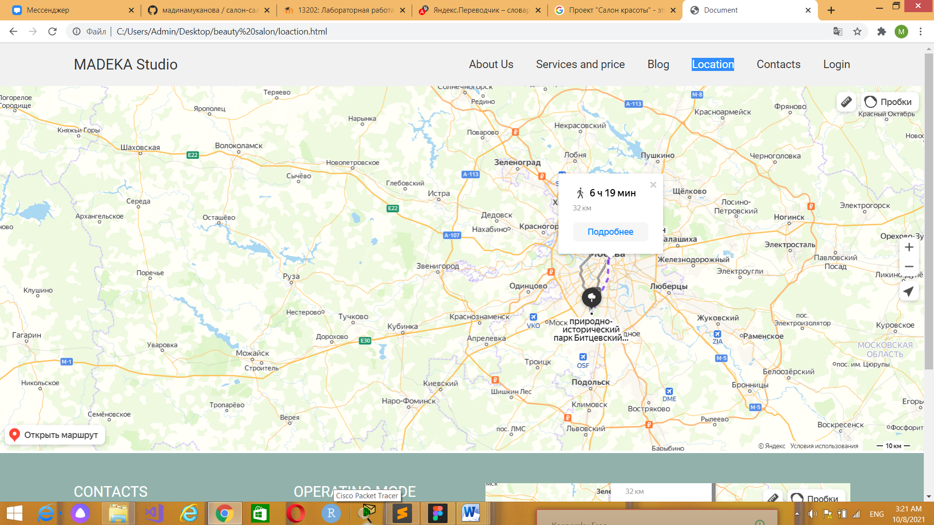

CONTACTS PAGE:

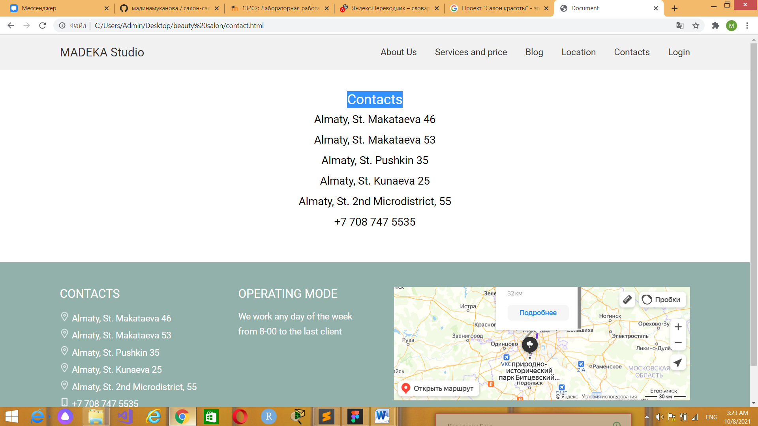

LOG IN PAGE:

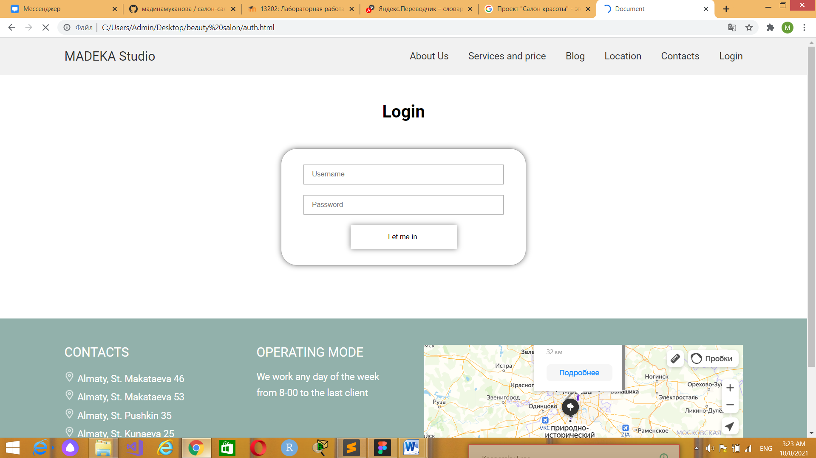

**Conclusion**

Despite any sanctions in the country, the salon business continues to develop. The desire to be beautiful or beautiful, to look better, younger, and often just gorgeous is ineradicable. Visiting a beauty salon for many representatives of the fair sex is a real holiday that lifts the mood and allows the girl to increase her self-esteem, feeling irresistible. Every modern woman has such an opportunity. To do this, you just need to come to a beauty salon and give specialists the opportunity to do their job in the best way.

**References:**

1. http://www.esfir.kz/
2. <http://www.kremlinrus.ru/article/863/71579/>

**Link to github:**

https://github.com/madinamukanova/beauty-salon-web